Institute of technology of Cambodia

Department of Information and communication Engineering



TP4-Decision marking

TP: Algorithm and Programming

Lecturer: BOU CHANNA

Student: VEN THON

ID: e20191250

Group: I3-GIC-C

Year: 2021-2022

Contents

Problem1Write a C program show about positive and negative number 2

Problem2 Write a C progam show about even or odd number 3

Problem3 Write a C progam to be get minimum number 4

Problem4 Write a C program show quadratic equation 5

Problem5 Write a C program show about gender name, and salary 6

This TP is taking about :

-Condition and lopp

-Operator(+,-, * ,/,%)

-Used AND OR ||

-Used if , else , else if

Problem1: Write a C program to get a number from a user.

The program check and tell whether this input number is

positive or negative number.

---- >   >=

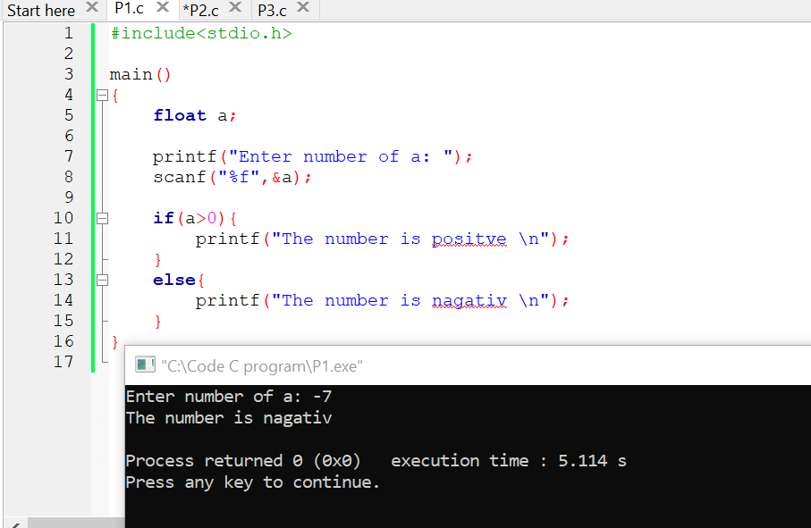

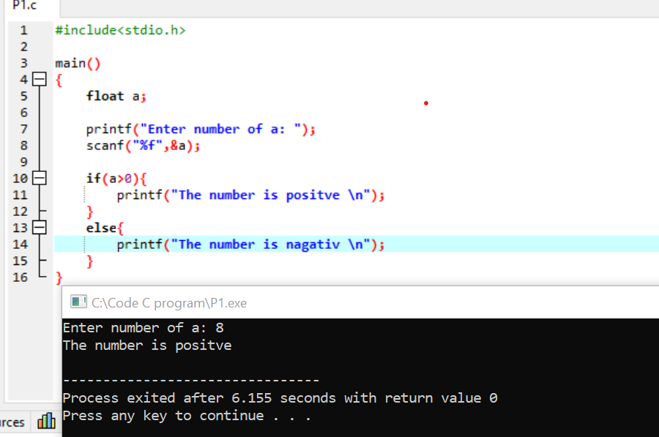

Problem2- Write a C program to get a number from a user.

The program check and tell whether this input number is

even or odd number.

---- %   ==

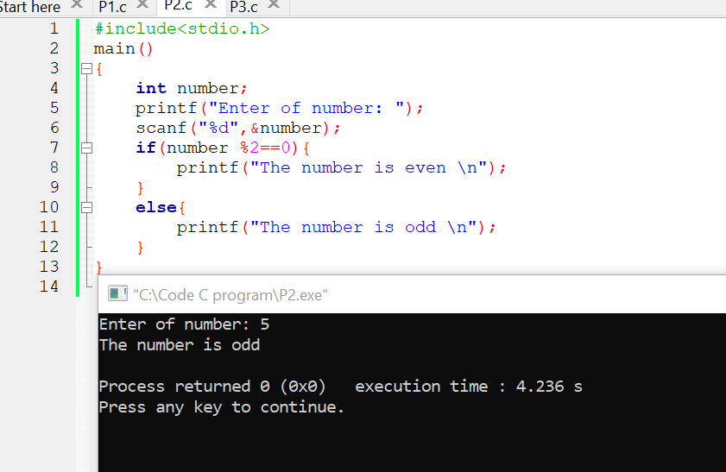

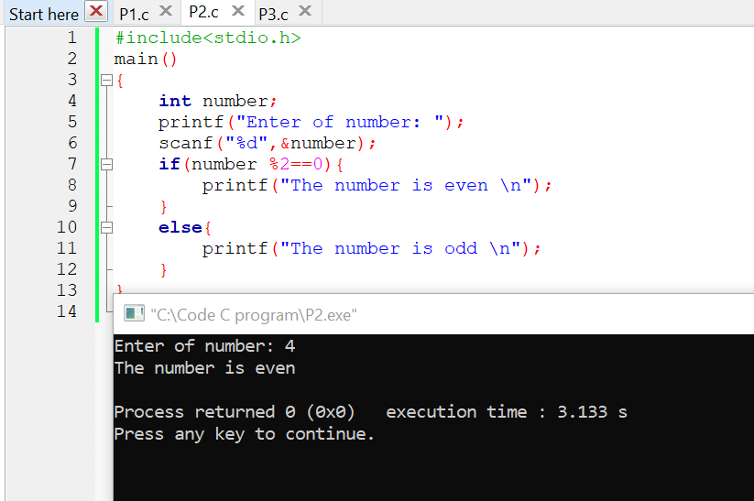

Problem3- Write a C program to ask a user for 7 numbers

(7 variables).

Find the minimum number and display on screen.

E.g

Input n1: 2

Input n2: 99

Input n3: 1

Input n4: 2

Input n5: 9

Input n6: -7

Input n7: 5

  => Output: The minimum number is -7.

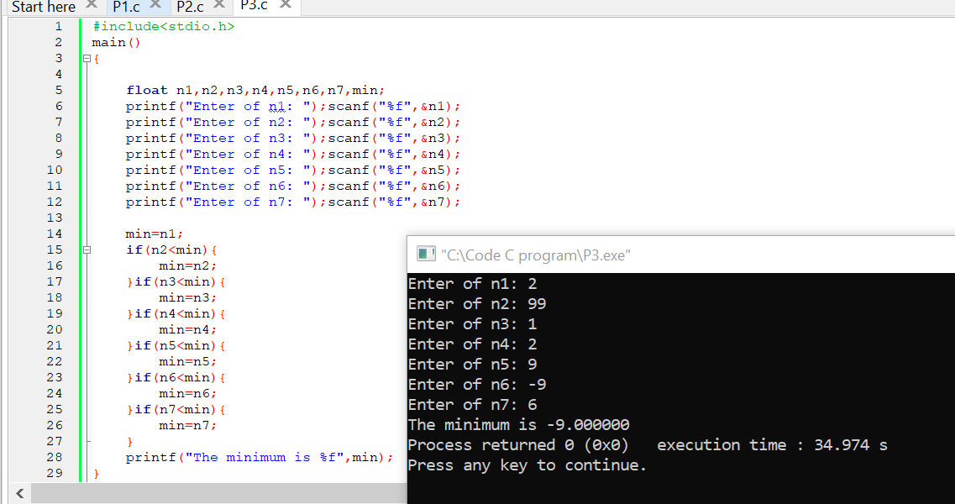

Problem4- Write a C program to solve the quadratic equation ax^2+bx+c=0.

Ask a user to inputs the coefficient a, b and c. The program calculate delta and find roots of the equation.

  Display the result (roots of the equation) on screen.

E.g:

Input a: 1

Input b: 4

Input c: 3

=> Output: The equation has roots: x1=-1 and x2=-3

Remark: Make sure you verify the result from program whether it is correct if we do it manually by hand.

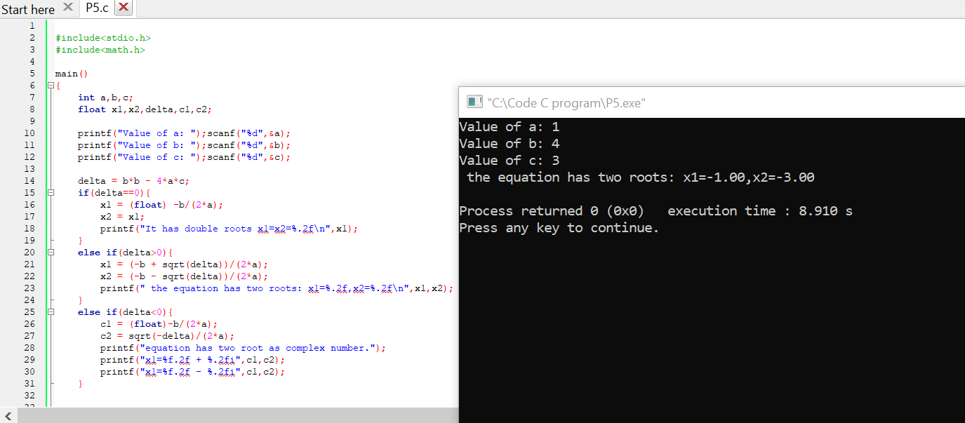

Problem5- Write a C program to tell how much tax a person should pay based on his/her salary and gender.

The program ask a user for gender, name, and salary (US dollar). The tax is based on the following rules:

-pay tax 10%, for male and salary is more than 300 USD.

-pay tax 5%, for male and salary is in between 200USD and 300 USD.

-pay tax 5%, for female and salary is more than 300 USD.

-pay tax 3%, for female and salary is in between  250 USD and 300USD.

-Otherwise, no need to pay tax.

gender=='M'

gender=="Male"     if(strcmp(gender,"Male")==0)

E.g:

Input gender: F

Input name:  Dara

Input salary (USD): 280

=> Output:

Hi Dara, based on your given information, the tax salary that you need to pay is: 8.4 USD.

Final salary to received is: 280 - 8.4 = 271.6 $

